# Lab 07_03 -- Chapter 07 – Sortation and Multidimensional Arrays

## Lab Description:

This lab will have you practice working this sorting arrays and working with multidimensional arrays.

## Lab Requirements:

1. Create a class called ArrayPlay.java
2. Organize your code to do the following items below using several methods.

### BubbleSort Requirements

1. Create and populate an array of integers to hold 10 random unsorted values.
2. Create a method called bubbleSort that accepts the array and sorts it in ascending order
3. Output the sorted array

### SelectionSort or InsertionSort Requirements

1. Create another array that holds 10 values and populate it with 10 random unsorted values
2. Create a method called selectionSort or insertionSort that accepts the array and sorts it in ascending order.
3. Output the sorted array

### DescendingSort Requirements

1. Create another array that holds 10 values and populate it with 10 random unsorted values
2. Create a method called descendingSort that accepts the array and sorts it in descending order.
   1. Use any sorting algorithm you wish, but you must create it.
3. Output the sorted array

### MultiDimensional Array Requirements

1. The roaches are back. Use a 2D array to create the following grid

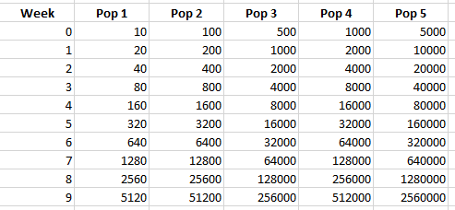

1. Assume the roach populations all double each week
   1. Use arithmetic to determine values
      1. Don’t input each value
2. Use Java formatting conventions
3. Use comments where appropriate
4. Submit your source code